**INFORMATION SYSTEM & INFORMATION TECHNOLOGY**

* **Information: -** An information is a meaningful. Many data is a one information.

Information can be used as output for the computer system. When data is processed, organized, structured presented in a given context .

* **Characteristic of an Information :-**

**Availability/accessibility:-**Information should be easy to obtain or access.

**Accuracy :-**Information needs to be accurate for the use to which it is going to be put.

**Reliability or objectivity:-**Reliability deals with the truth of information or the objectivity with which it is presented.

**Completeness:-**Information should contain all the details required by the user.

**Presentation:-**The presentation of information is important to the user.

**Timing:-**Information must be on time for the purpose for which it is required.

* **Technology: -** It is the collection of techniques, skills, methods and processes used in the production of goods or services.
* **Information Technology:** Information technology (IT) is the application of computers to store, study, retrieve, transmit, and manipulate data, or information. Example-Telephone, Radio, Computer etc.
* **Information System** :- An information system (IS) is an organized system for the collection, organization, storage and communication of information. Example-Computer, Mobile etc.
* **Characteristics of Information System :-**

It can be organized data into information.

Analysis of an information to give knowledge.

An information system is a system that provides information according to a user’s requests.

* **Management :-** Management is an individual or a group of individuals that accept responsibilities to run an organisation.
* **Thinking :**- Thinking  is a process something that should be done in a certain way.
* **Planning :**- Planning is preparing a sequence of action steps to achieve some specific goal.
* **Deciding:**- Deciding is a process to make a choice about (something) and to choose (something) after thinking about it .
* **Different Level of Management :**- There are 3 level management as:-

**Top Level Management**:- The top level management determines the objectives, polices and plans of the organisation. The top level management does mostly the work of thinking, planning and deciding. Example-CEO, BOD etc.

**Middle Level Management**:-The middle level management give the advice to the top level management. It execute the polices and plans which are given by the top level management. Example-Branch Manager,HOD etc.

**Lower Level Management** :- The lower level management inform the workers about the decision which are taken by the management. They have important responsibility to getting the work done from workers. Example-Employee, Supervisior etc.

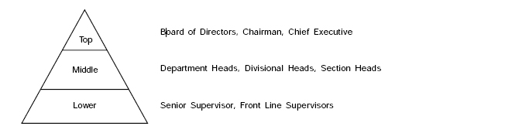

* **Type of Information and Level of Management :-**

There are 3 types of information and level of Management as :-

**Strategic information:**  Strategic information is the top level management. Strategic information is used by man­agers to define goals and priorities, initiate new programmes and develop policies.

**Tactical information:** Tactical information helps middle level man­agers allocating resources and establishing controls to implement the top level plans of the organisation.

**Operational information:** Operational information relates to the day-to-day operations of the organisation.It can be control over the organisation.It is a lower level management. It can be easily measurable.

